***Laptop Price Predictor***

# Model Building

Initial dataset:

Total rows = 1302

Total columns = 11

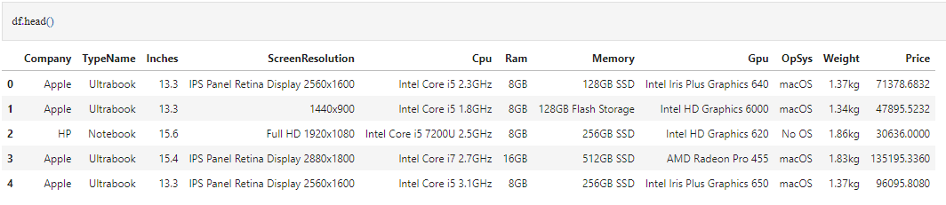

## Data Cleaning

1. Removed duplicate rows
2. Removed the word ‘GB’ from ‘*Ram*’ column and ‘kg’ from ‘*Weight*’ column
3. Changed data type of ‘*Ram*’ from object to int and *‘Weight’* from object to float

## Data Preprocessing

* ['*ScreenResolution*' column has inconsistent type of values and a large number of categories which is unsuitable for encoding]

1. Adding a new column '*Touch Screen*' from the '*ScreenResolution*' column.
2. Adding a new column '*IPS*' from the '*ScreenResolution*' column.
3. Adding 2 new columns '*X_resolution*' and '*Y_resolution*' from the '*ScreenResolution*' column.

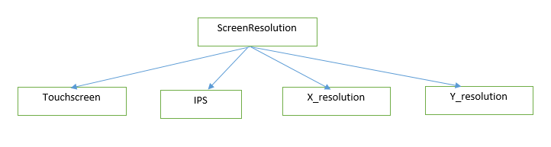

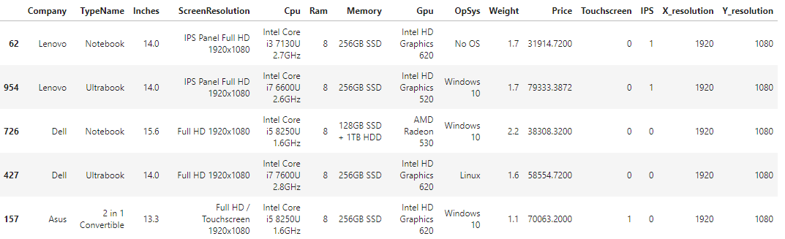

1. Combining '*X_resolution*', '*Y_resolution*' and '*Inches*' to form a new column '*PPI*' (Pixels Per Inch)
$PPI=\frac{√({X_{resolution}}^{2}+ {Y_{resolution}}^{2})}{inches}$

2. Dropping '*ScreenResolution*', *'Inches*', '*X_resolution*' and '*Y_resolution*' columns

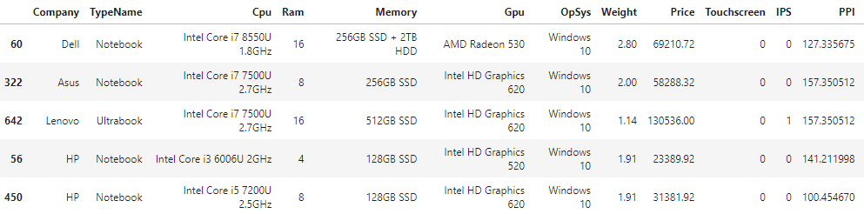

* [‘*Cpu*’ column has too many categories]

1. Adding a new column '*Cpu Name*' which stores the first 3 words of '*Cpu*' column
2. Adding a new column '*Cpu Brand*' from ‘*Cpu Name*’ which will have the 5 categories - Intel Core i7, Intel Core i5, Intel Core i3, Other Intel Processor and AMD Processor

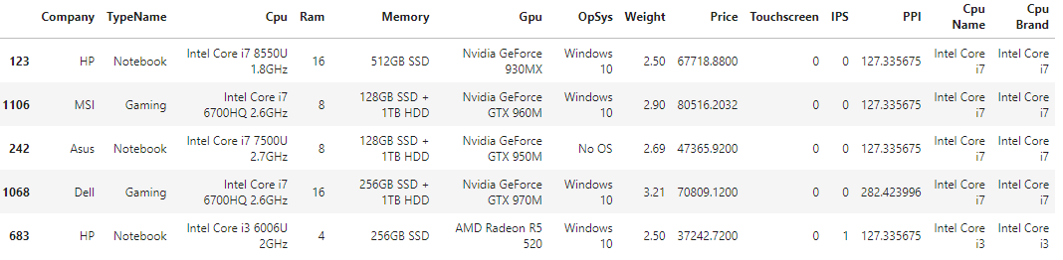

1. Dropping '*Cpu*' and '*Cpu Name*' columns

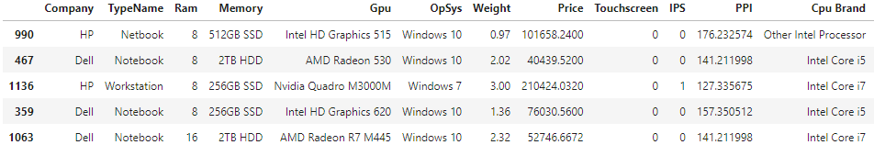

* [‘*Gpu*’ column has too many categories]

1. Adding a new column '*Gpu Brand*' which contains the first word of *'Gpu*' column
2. Dropping '*Gpu*' column

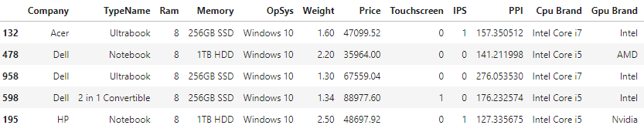

* [‘*OpSys*’ column has too many categories]

1. Adding a new column '*OS*' from ‘*OpSys*’ which will have 4 categories - Windows, Linux, No OS and Others
2. Dropping '*OpSys*' column

* [‘*Memory*’ column has too many categories]

1. Dropping '*Memory*' column

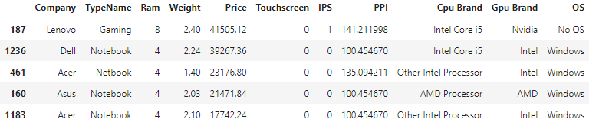

## Modeling

X = [Company, TypeName, Ram, Weight, Touchscreen, IPS, PPI, Cpu Brand, Gpu Brand, OS]

y = [Price]





















| Model | Hyper-parameters | R2 score |
| --- | --- | --- |
| Linear Regression | None | 81.72 |
| Ridge Regression | alpha = 1 | 81.95 |
| Lasso Regression | alpha = 0.001 | 81.53 |
| KNN Regression | n_neighbors= 5 | 85.11 |
| Decision Tree Regression | max_depth=5 | 77.92 |

## Model Selection

Selected model (based on R2 score) = KNN Regression

## Exporting model





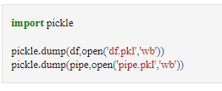





2 files - ‘df.pkl’ and ‘pipe.pkl’ will be created in the current folder.

# Model Deployment

## Building the User Interface (using Streamlit)

1. Create a new Pycharm project ‘Laptop_Price_Predictor’
2. Copy the 2 files df.pkl and pipe.pkl in ‘Laptop_Price_Predictor’ folder

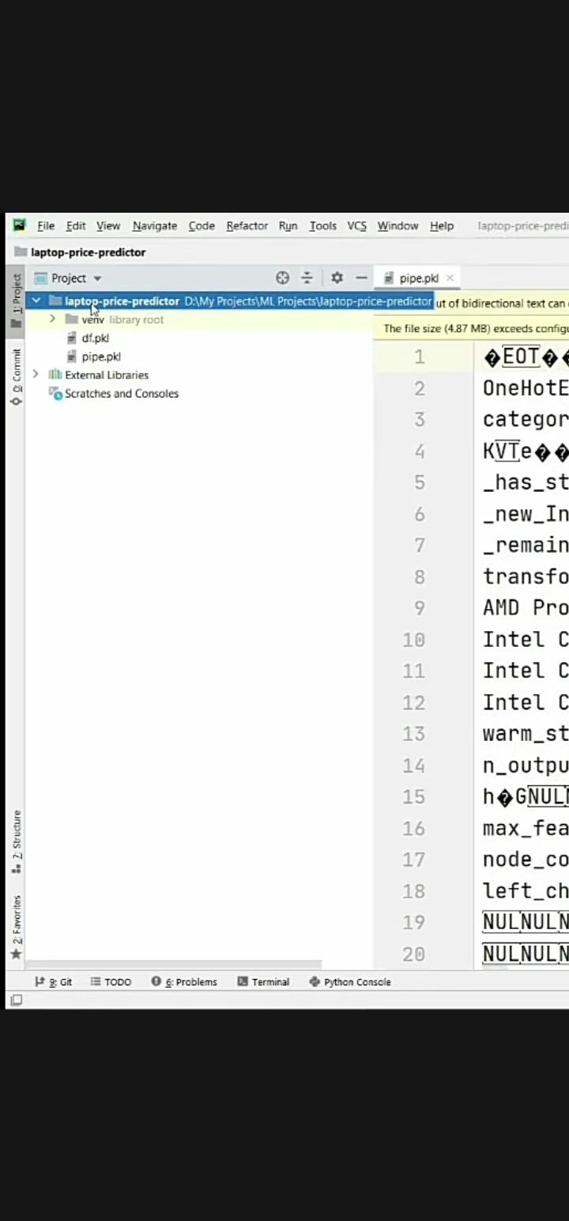

1. Create a new python file in this folder named ‘app.py’

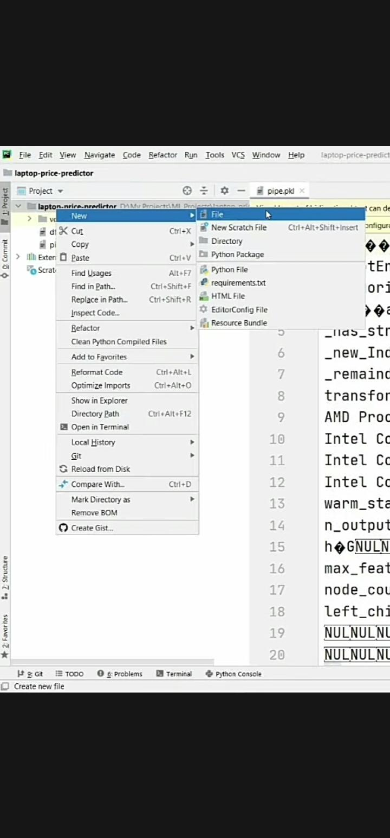

1. In the terminal, write -

*pip install streamlit*

*pip install sklearn*

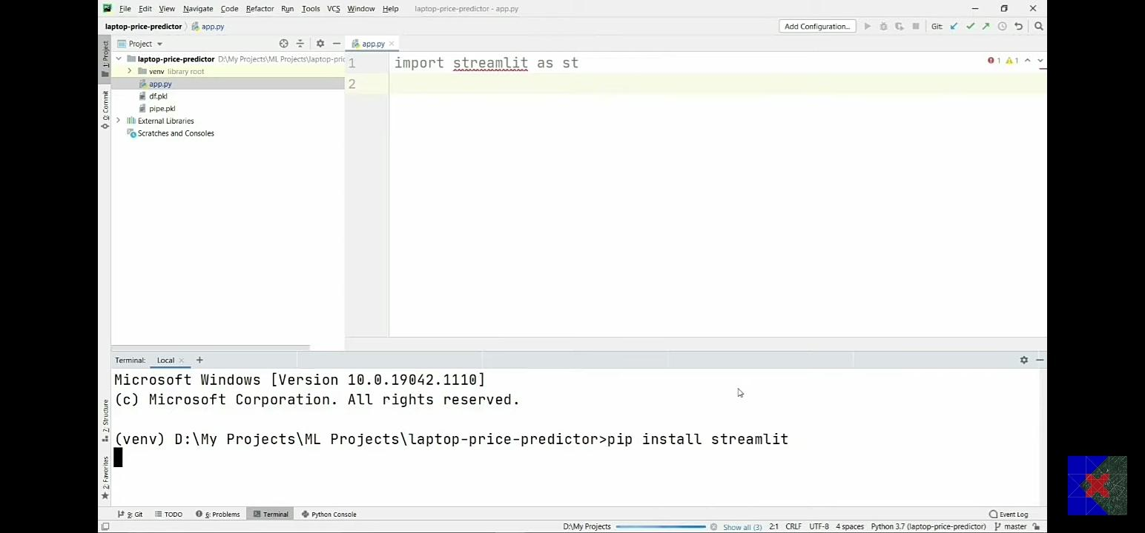

1. Write the following code in app.py -

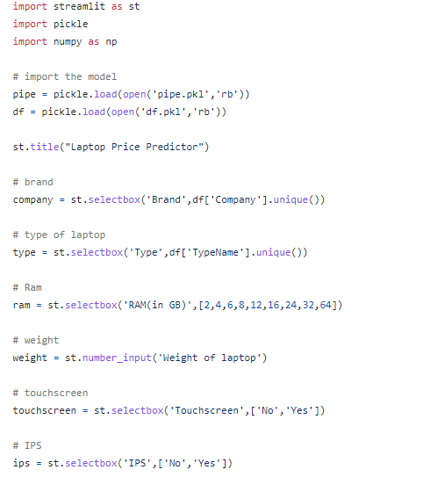

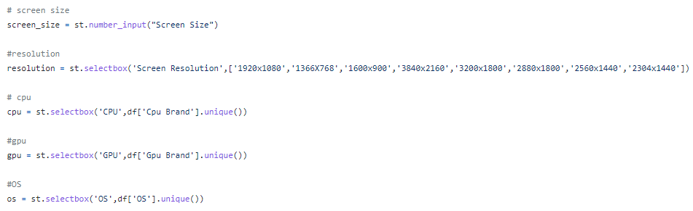

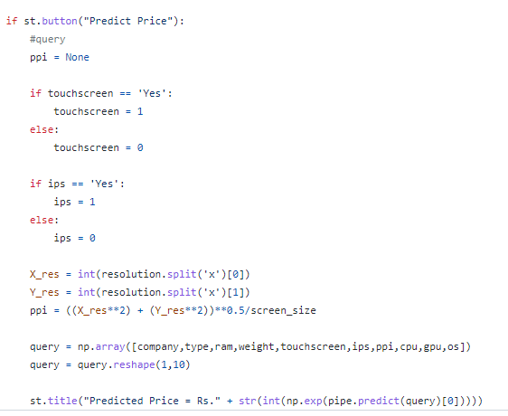

1. To check if the code is running properly, write this code in the terminal -

*streamlit run app.py*

Browser window will look like this -

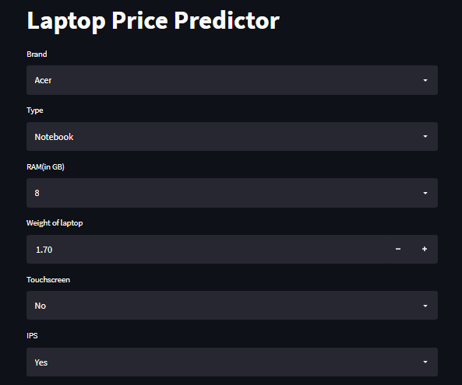

## Deploying (using Heroku)

1. Create a new file named ‘.gitignore ‘ in the ‘Laptop_Price_Predictor’ folder.
2. In this file, write the name of the virtual environment folder -

*venv*

1. Create a new file named ‘setup.sh ‘ in the ‘Laptop_Price_Predictor’ folder.
2. Write the following code in this file (for creating directory in Heroku) -

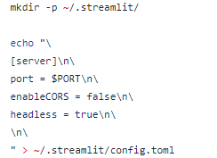

1. Create a new file named ‘Procfile ‘ in the ‘Laptop_Price_Predictor’ folder.
2. Write the following code in this file (for running the app in Heroku) -

*web: sh setup.sh && streamlit run app.py*

1. Create a new file named ‘requirements.txt ‘ in the ‘Laptop_Price_Predictor’ folder.
2. Write the name of required libraries in this file -

*streamlit~=1.5.1*

*sklearn*

1. Login to Heroku account
2. Click on New -> Create a new app

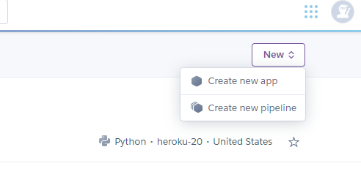

1. Give the App name and select a region. Then click on Create app.

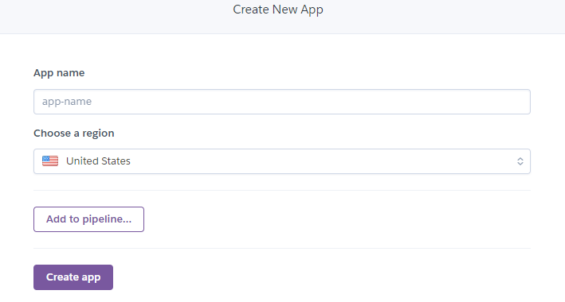

1. Download and install Heroku CLI
2. In the Pycharm project terminal, write this and press Enter -

*git init*

1. Then write this and press Enter -

*heroku git:remote -a laptop-price-predictor-sh*

1. Then write this and press Enter -

*git add .*

1. Then write this and press Enter -

*git commit -am "make it better"*

1. Then write this and press Enter -

*git push heroku master*